**PROJECT REPORT TEMPLATE**

**CRM APPLICATION THAT HELPS TO BOOK A VISA SLOT**

# INTRODUCTION

**1.1 OVERVIEW**

(i) A visa slot management project is a system that is used to track and manage the availability of visa slots, which are appointments that are required for certain visa application.

|  |
| --- |
| (ii)  (iii)  (iv)  (v)  (vi) |

It might be used by a government agency or a visa processing center To schedule and manage appointments with applicants.

The concept of customer relationship management (CRM) aims to streamline the approach of organizations toward their customers.

It includes documentation of customer data so that it can be used for information analysis, evaluation, and future planning.

For immigration consultants, it is very important to maintain proper records of potential clients as well as existing customers.

Investing in a CRM system is undoubtedly very fruitful not just for small & medium sized organizations but for large ones as well.

**1.2 Purpose**

* 1. Customer relationship management (CRM) is a technology for managing all your company’s relationships and interactions with customers and potential customers.
  2. The goal is simple. Improve business relationships.
  3. A CRM system helps companies stay connected to customers, streamline processes, and improve profitability.
  4. with a CRM solution, the sales and marketing team can track and follow a customer’s interaction journey with your business.
  5. This can enhance the customer journey and experience by refining each customer touchpoint.

# Problem definition & Design thinking

**2.1 Empathy Map**

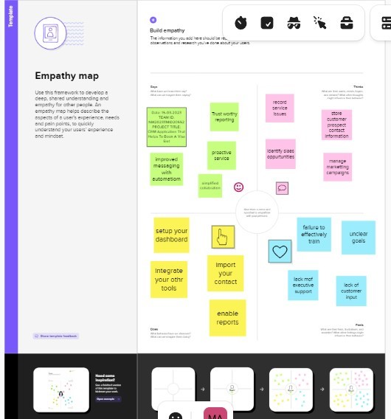

**2.2 Ideation & Brainstorming Map**

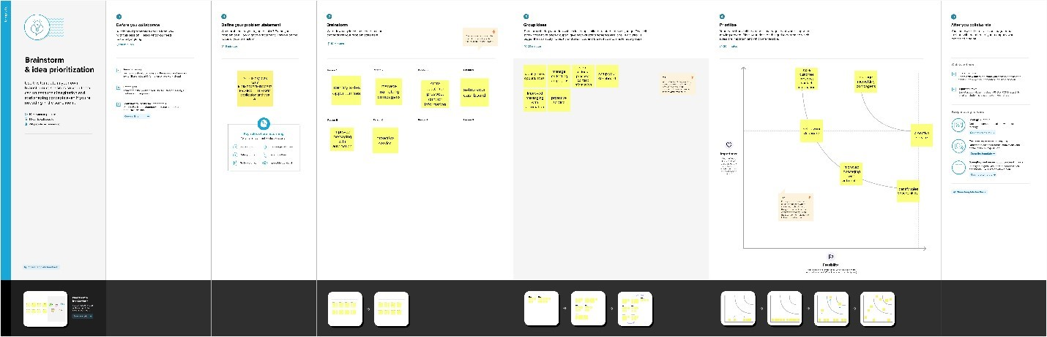

# RESULT

**3.1 Data Model:**

**Object name**

**Fields in the object**

**Passport**

**Field label**

**Data type**

Full name

Text

Passport number

Text

Contact number

Number

Permanent address

Text

**Visa slot**

**Field label**

**Data type**

location

Text

time

Number

Passport number

Text

Visa slot number

Number

**Payment**

**Field label**

**Data type**

Payment mode

Text

Card number

Number

Transaction id

Text

Cancel transaction

Text

Visa slot number

Number

**Reschedule**

**Field label**

**Data type**

Passport number

Text

Location

Text

Time

Number

cancel

Text

Status

Text

**3.2 Activity & Screenshot**

**Milstone 1:**

**Activity 1:**

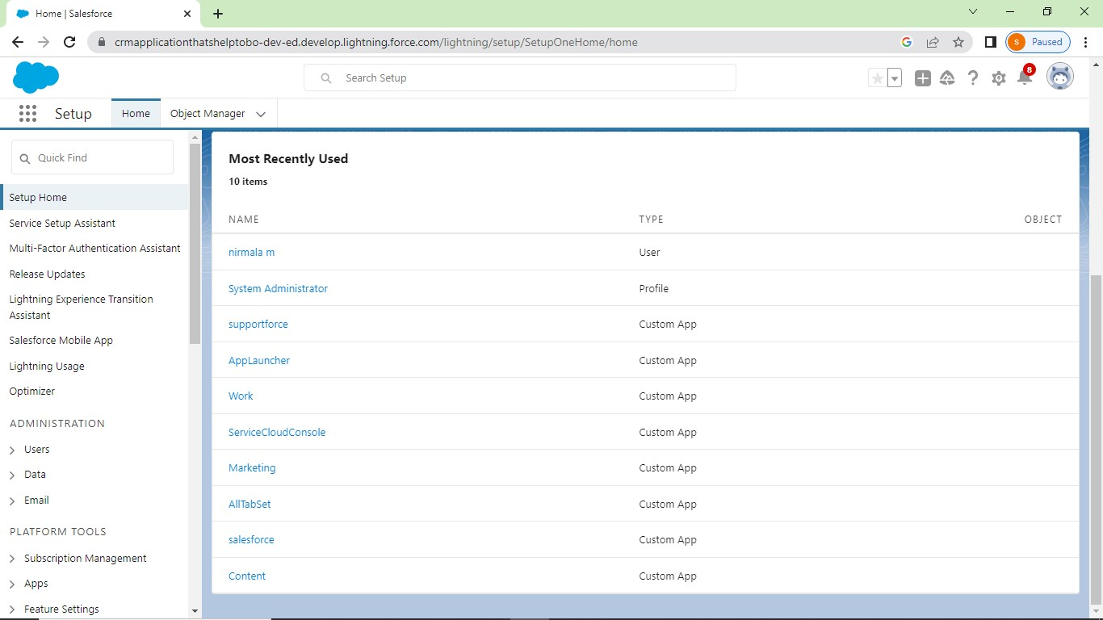

**Milstone 2:**

**Activity 1:**

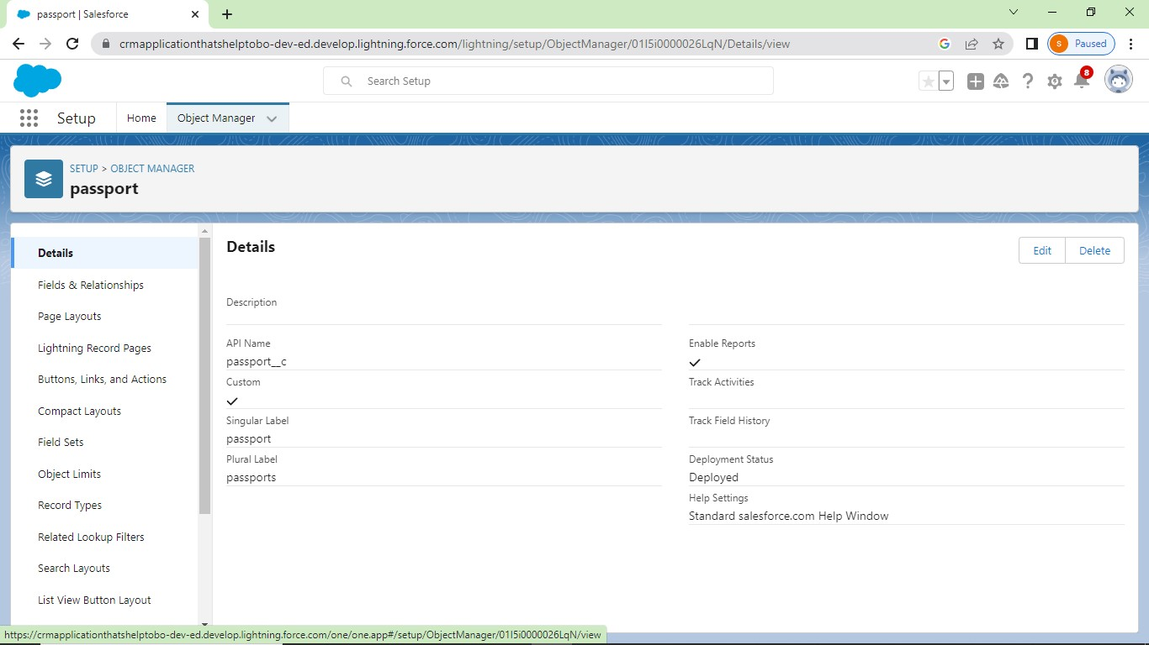

**Activity 2:**

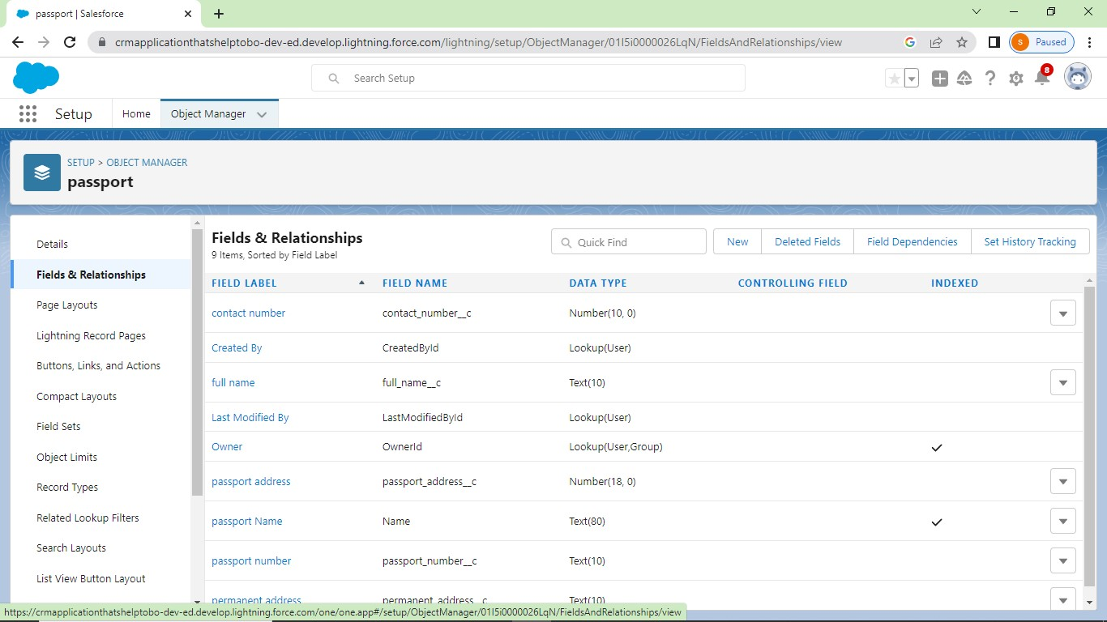

**Milstone 3:**

**Activity 1:**

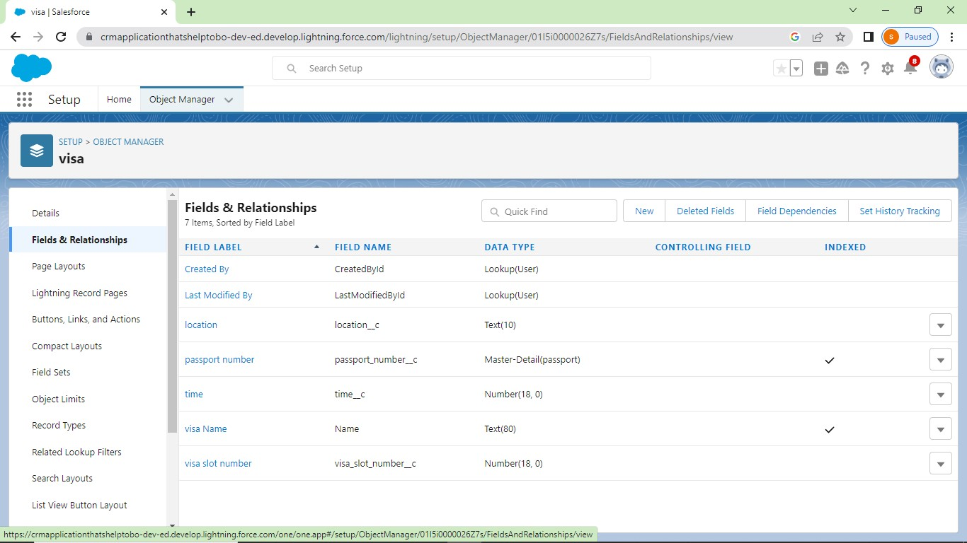

**Milstone 4:**

**Activity 1**

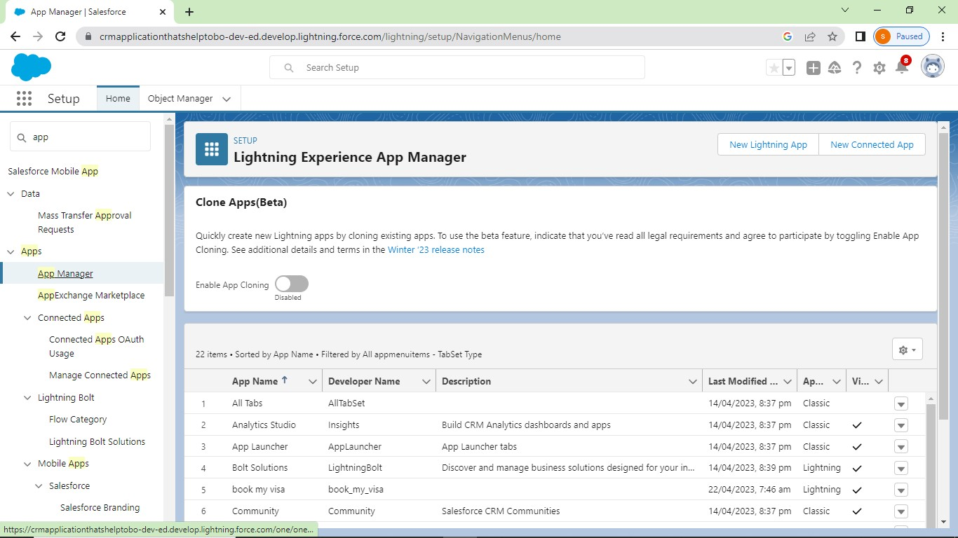

**Milstone 5:**

**Activity 1:**

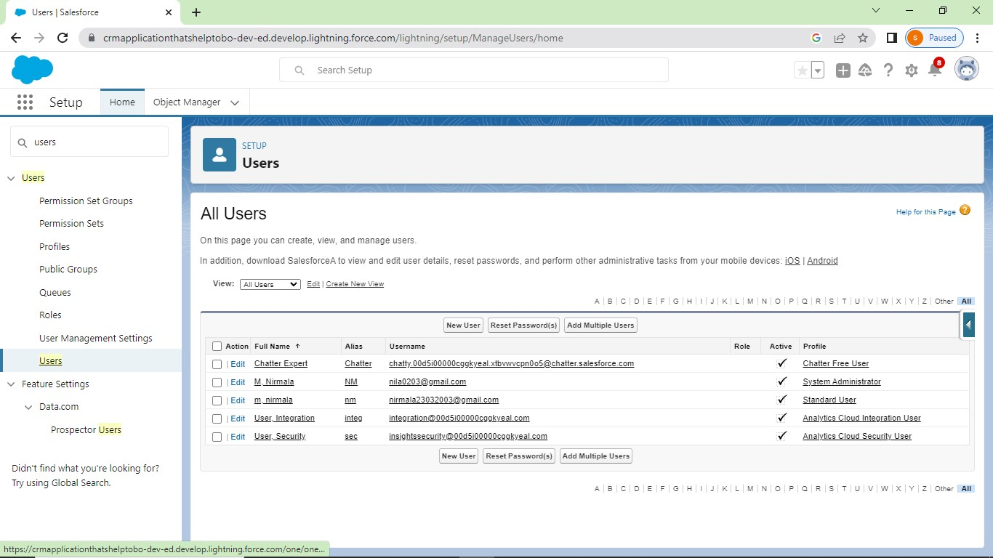

**Activity 2:**

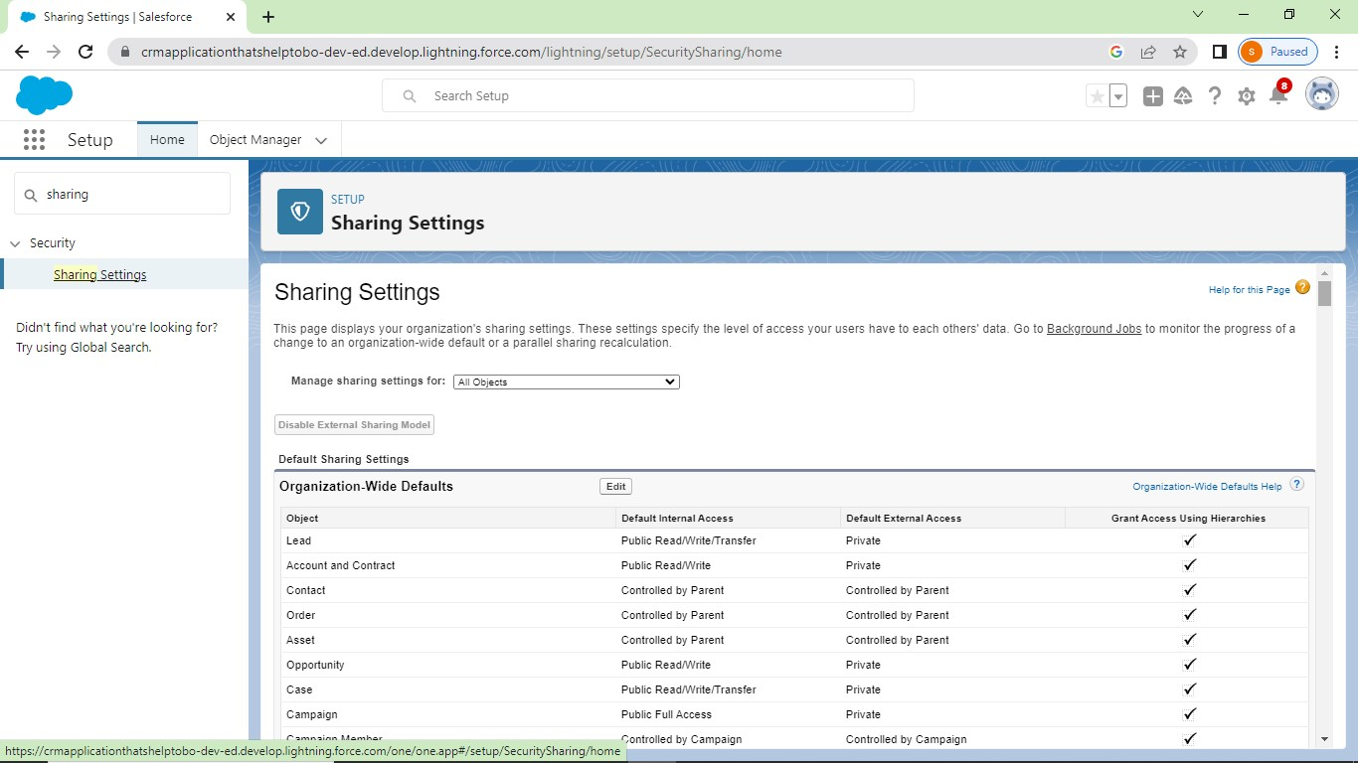

**Milstone 6:**

**Activity1:**

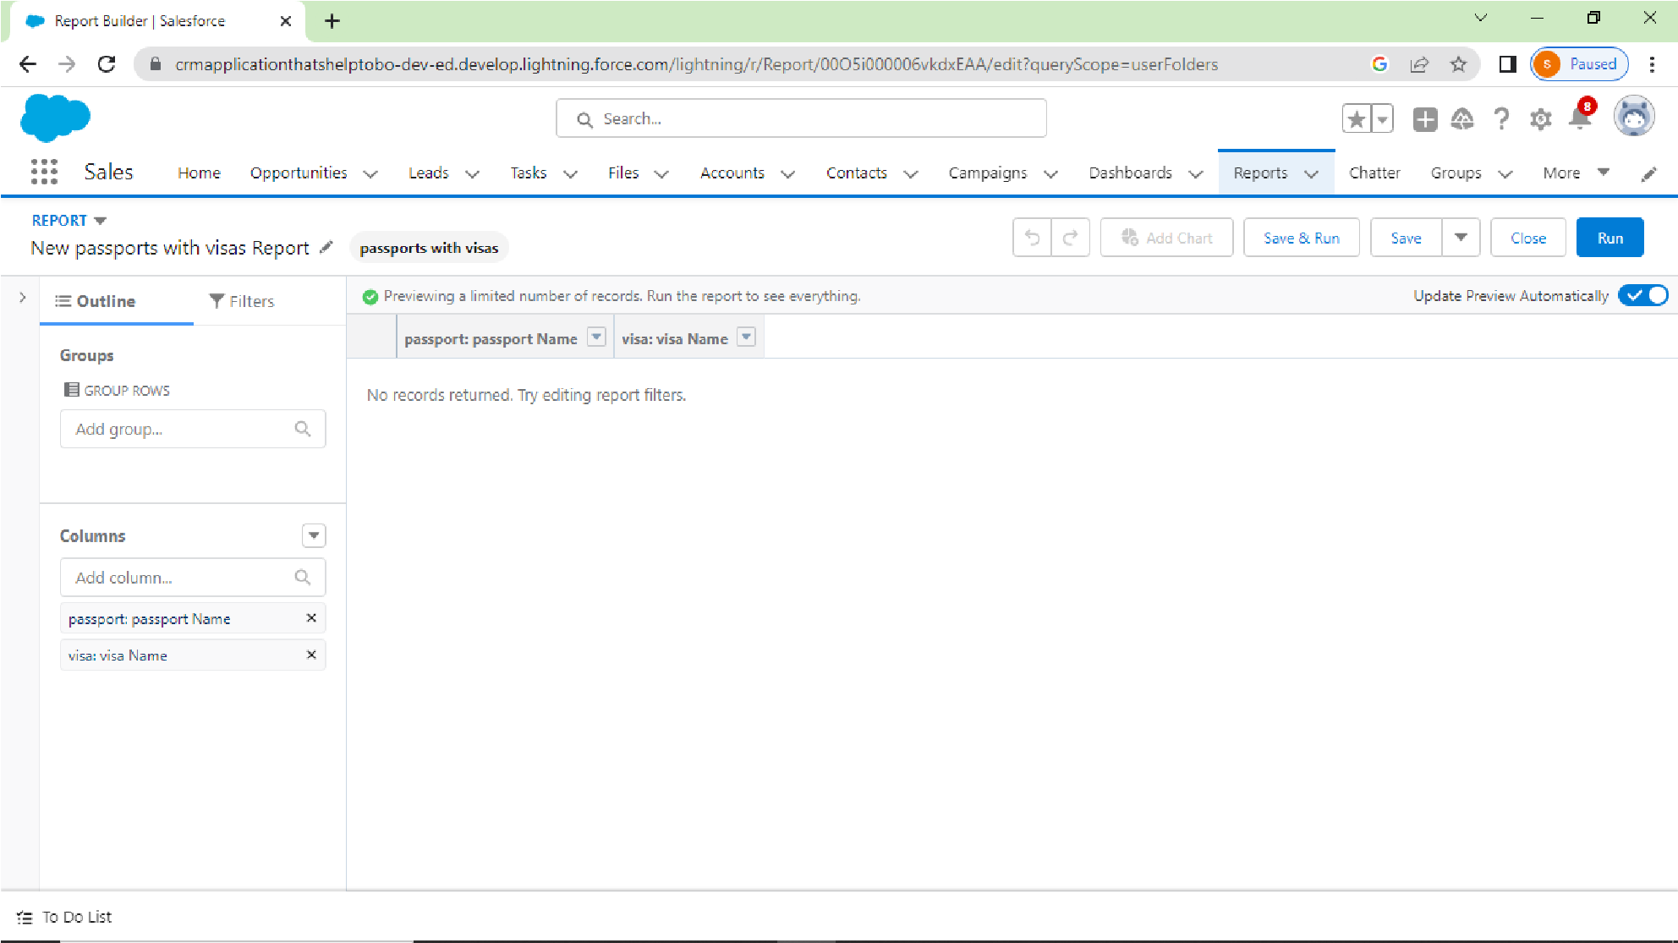

**Milstone 7:**

**Activity:**

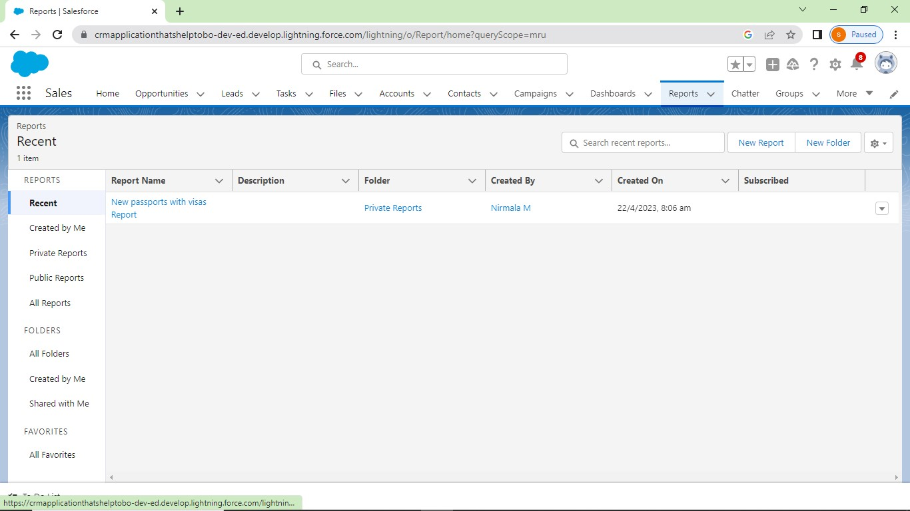

# Trailhead profile public URL

**Team lead: Nirmala.M**

[**http://trailblazer.me/id/nbscstatistics**](http://trailblazer.me/id/nbscstatistics)

**Team member 1: Menaga.E**

<https://trailblazer.me/id/menae1>

**Team member 2: Madhumitha.M**

[**https://trailblazer.me/id/mmathumitha1**](https://trailblazer.me/id/mmathumitha1)

**Team member 3:Paunraj**

**5.Advantages & Disadvantages**

**Advantages:**

1. Improved informational organizations.
2. CRM for enhanced communication.
3. CRM improves your customer service.
4. Automation of every tasks.
5. Greater efficiency for multiple terms.
6. Improved analytical data and reporting.

**Disadvantages:**

* 1. CRM costs. one of the greatest challenges to CRM implementation is cost.
  2. Business culture. A lack of commitments or ressistance to cultural change from people within the company can cause major difficulties with CRM implementation.
  3. Poor communication. (iv) Lack of leadership.

1. **Applications** 
   1. As customers have various products or services to choose from, it becomes challenging for businesses to position themselves in the market.
   2. As a result, customers make their purchase decisions based on their experience with the business.
   3. Hence, it becomes necessary for a company to offer an excellent customer experience (CX). For that, businesses require complete knowledge of customer data.
   4. CRM systems collect necessary data from several sources such as email, websites, marketing campaigns, advertising campaigns, and physical stores.
   5. All these data are placed together to develop CRM solutions and enhance the customer experience.

1. **Conclusion** 
   1. The term Customer Relationship Management (CRM) describes systems and processes within companies which, with the help of customer data, aim to unify and improve customer service in order to achieve higher levels of customer loyalty.
   2. Customer Relationship Management brings together various departments, such as sales and marketing, to ensure a uniform approach which ultimately contributes to increasing the company’s success.
   3. Unlike many other corporate guidelines, CRM focuses on the customer and customer relationships rather than on sales or profits.
   4. This approach is particularly widespread in the business-to-business (B2B) area where it is often very difficult for companies to attract new customers.
   5. Although online marketing has made things much easier and opened up new solutions, business-to-business still remains a sector where it is difficult, and above all expensive, for any company to acquire fresh customers.
   6. Customer relationship management is also used in the business-to-consumer area, though it plays a somewhat different role here because CRM for business customers is usually based on processes and solutions that are specifically tailored to individual customers.

**8.Future scope**

* 1. CRM is predicted to become more powerful to support customer first, not company first businesses.
  2. Bringing together disparate teams, data, and system integrations, the CRM of the future is set to be centralized and empowered by AI and mobile capabilities.
  3. Defining the scope of CRM projects means figuring out which areas of your business need to be included in the CRM implementation plan.
  4. Before any CRM initiative begins, scoping is essential to establish what the effort will and will not cover, as well as to prevent feature creep and project bloating.